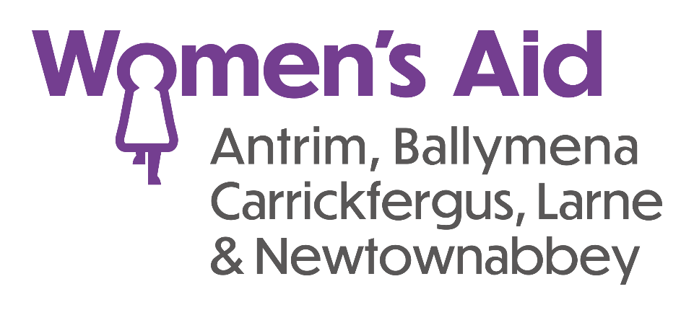
A P P L I C A T I O N F O R M

Reference Number: DASRA/

Closing Date: Thursday 18th April 2024 at 12 noon.

Note: Women’s Aid ABCLN is a women only organisation and the lawful recruitment of a female(s) for the post(s) falls within the exemption stated in Article 10 (2B and 2E) of sex discrimination (NI) order 1976. Women’s Aid ABCLN is a registered charity supporting Equal Opportunities Policies. We welcome applications from all areas of the community.

Please complete and return to: recruitment@womensaidabcln.org

Recruitment Officer

Women’s Aid ABCLN

2 Cullybackey Road
Ballymena
BT43 5DF
OFFICIAL USE ONLY
Date Application Form received:  Time:  Received by:  Interview: YES / NO  Interview date & time:  Notified on:  SUCCESSFUL / UNSUCCESSFUL / RESERVE |  | √ | DATE
 | Ref one received
 | Ref two received
 | Qualifications checked
 | Access NI complete

CONFIDENTIAL

Position applied for: DAS RA 37hrs DAS RA 21hrs
please tick position/s applied for

Personal Details
Surname: | Preferred title:
Forenames:
Home address:

Telephone: Day Evening
Email Address: |  | National Insurance No:

Qualifications

Level e.g. GCSE, Degree | Title / Subject | Grade Attained

Paid Employment / Voluntary Work
Please start with your present role and work backwards.

Dates  From – To | Employer’s Name  and address | Job title and Key responsibilities | Full-time/  part-time/  no. hours per week | Reason for  leaving

Use this space to clearly evidence how you meet the essential criteria. (please include dates)

Training Courses
Please give details of any relevant external or internal courses or training

Date | Course Title | Length of Course

Supporting Statement and additional relevant Information

Please use the space below to outline why you applied for the role and provide any additional information that you feel is relevant to the position applied for.

Candidates need to be aware that it is the policy of the organisation to obtain an Access NI Enhanced Disclosure on each employee before they commence their employment with the organisation. (This requirement is applicable only to candidates we would wish to appoint).

A copy of the Access NI Code of Practice is available on request.

Women’s Aid ABCLN has a policy on the recruitment of ex-offenders. Please note that disclosure of a conviction does not necessarily debar any applicant from obtaining employment.
Your answers will be treated with the strictest confidence.

Do you have any convictions that are not “protected” as defined by the Rehabilitation of Offenders (Exceptions) (Northern Ireland) Order 1979, as amended in 2014?

If the answer is “Yes” please give details

Is there any reason why you cannot work in regulated activity?

If the answer is “Yes” please give details ………………………………………………………………………

………………………………………………………………………………………………………………….

………………………………………………………………………………………………………………….

………………………………………………………………………………………………………………….

Right to Work in the UK

Do you need a work permit to work in the UK? Yes / No

Driving Ability

Do you hold a full current UK Driving Licence?
Note: to meet the requirements of the post you must have business insurance for your vehicle.

Do you have a car or can you access transport to enable you to work in various locations, if necessary?

References:

Please give details of two people whom we may contact for a reference. It is our policy to acquire both verbal and written references so please provide a postal address and contact number. References will be taken up immediately following acceptance of offer unless you specify otherwise. One referee should have knowledge of you in a working environment, either paid or unpaid, and must be your current/ last employer.

We cannot accept references from relatives. If you are a recent school/ college leaver please give appropriate school/ college referees. Prior consent of referees should be obtained.

Name | Address | Telephone | Occupation of referee  State if employment was paid or unpaid
Postal:

Email:
Postal:

Email:

Disability
In accordance with the Disability Discrimination Act, a person is disabled if they have, or have had, “a physical or mental impairment which has, or has had, a substantial and long term adverse effect on their ability to carry out normal day-to-day activities”.

If you consider yourself to have or have had a disability that is relevant to the position for which you are applying please provide any relevant information about your requirements so that we can process your application fairly and make any reasonable arrangements/adjustments for your attendance at interview if shortlisted.
___________________________________________________________________________________________

___________________________________________________________________________________________
Women’s Aid ABCLN, as part of its Equal Opportunities Policy, welcomes applications from people with disabilities.

Are there any dates when you are not available for Interview?

What is your notice period with your current employer and if successful when would you be available
to take up the position?

Declaration
I declare that the information given in this form and in any accompanying documentation is true to the best of my knowledge and belief and give my permission for enquiries to be made to confirm qualifications, experience, date of employment, right to work in the UK and for the release by other people or organisations of necessary information to verify the content. I understand my application may be rejected and / or I may be dismissed following appointment if I have given any false or misleading information or have withheld any relevant details. I understand that employment with Women’s Aid ABCLN is subject to receipt of satisfactory references.

Signature of applicant …………………………………………….. Date

Privacy Notice
The data contained in this application form will only be used for the purpose of progressing this application for employment. The sensitive personal data on the attached monitoring form will only be used to comply with the requirement of statutory legislation.

The company will not share any of the information provided in your application with any third parties for marketing purposes or store any of your information outside the European Economic Area. The information you provide will be held securely by us and/or our data processors whether the information is in electronic or physical format.

We will use the contact details you provide to contact you to progress your application. We will use the other information you provide to assess your suitability for the role you have applied for. You do not have to provide what we ask for but it might affect your application if you don’t.

We do not collect more information than we need to fulfil our stated purposes and will not retain it for longer than is necessary.

Please return completed form and attachments to the address given on the front page.

For our information please tell us where you saw the advertisement for this post

Please complete and return this form, with the Monitoring Questionnaire by the date and time shown on the front of the form.

LATE APPLICATIONS WILL NOT BE CONSIDERED

MONITORING QUESTIONNAIRE
Strictly confidential

We are an Equal Opportunities Employer. We do not discriminate on grounds of religious belief or political opinion. We practice equality of opportunity in employment and select the best person for the job.
To demonstrate our commitment to equality of opportunity in employment we need to monitor the community background of our applicants and employees, as required by the Fair Employment and treatment (NI) Order 1998.
Please complete this questionnaire with every application.
TICK BOXES AS APPROPRIATE

- SEX MALE FEMALE

- DATE OF BIRTH _________________

- DISABILITY

Do you consider yourself to have a disability? Yes No

If yes, please indicate the nature of your disability by ticking the appropriate box(es).

MOBILITY DEXTERITY/CO-ORDINATION

VISION PSYCHIATRIC/MENTAL

HEARING LEARNING

SPEECH OTHER (Please specify) _______________________

- RACE / ETHNIC ORIGIN

WHITE CHINESE IRISH TRAVELLER

INDIAN BLACK AFRICAN BLACK CARRIBBEAN

PAKISTANI BANGLADESHI OTHER (Specify) __________

- FAIR EMPLOYMENT MONITORING INFORMATION
Please indicate the community to which you belong:

I belong to the Protestant Community

I belong to the Roman Catholic Community

I belong to neither the Protestant nor Roman Catholic Community

NB. This questionnaire should be returned with the application form.
THANK YOU FOR YOUR CO-OPERATION
Official Use Only Ref No: /

